LinkedIn Lookup Start Page

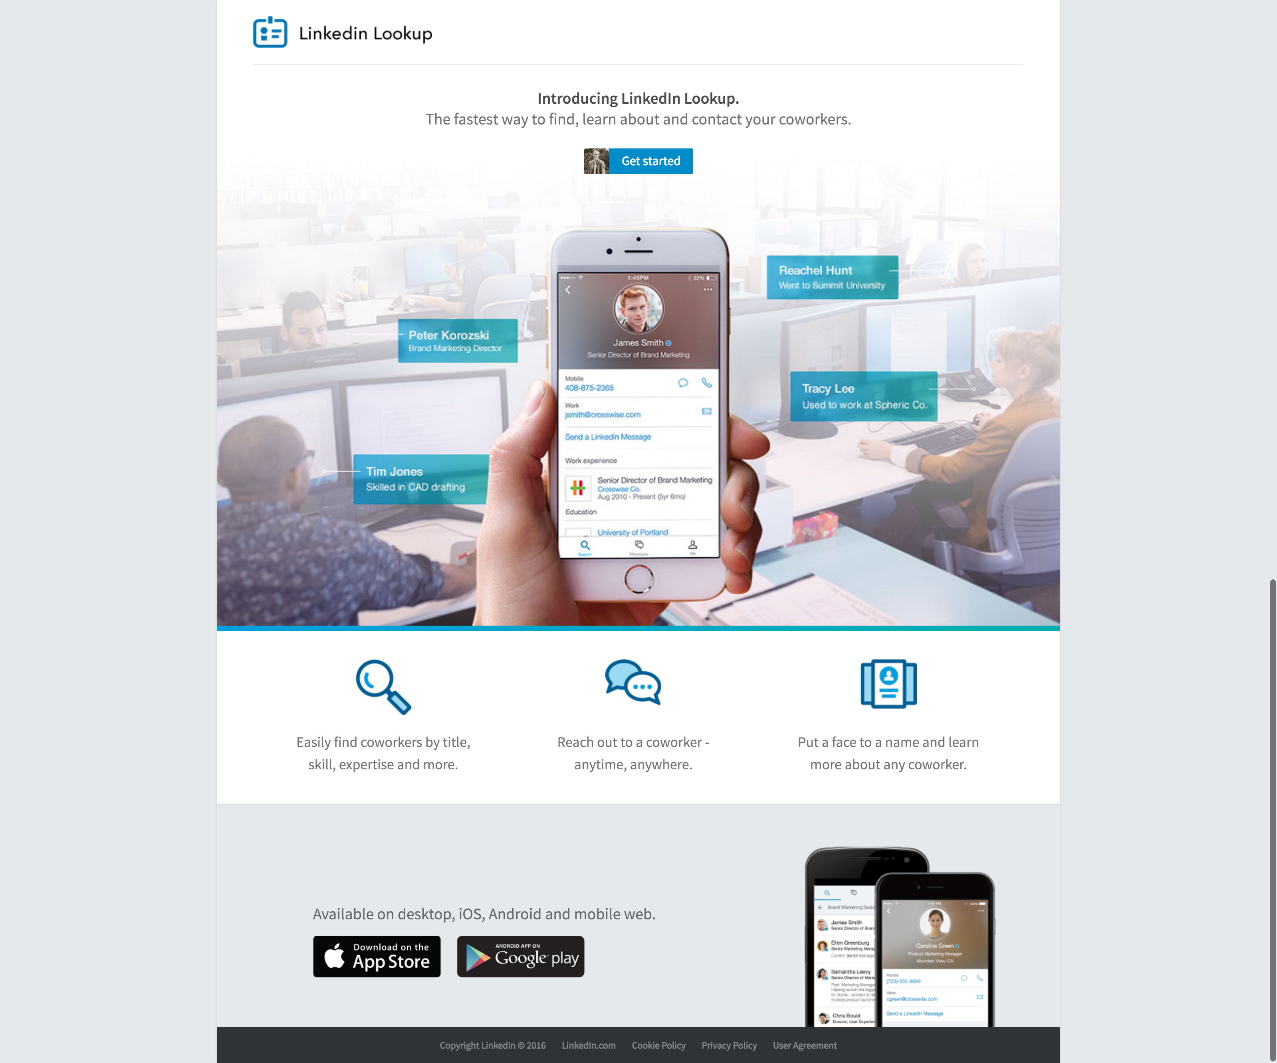

Notes:

* Nice Clean Page
* Makes the Purpose of the Offering Clear, but not the Platform
  + Is it a separate app? Can I just start using it?
* Does not make clear what my commitment is.
* UX Annoyance – Why is the Get Started button so small? I found it, but geez

Get Started Walk-Through

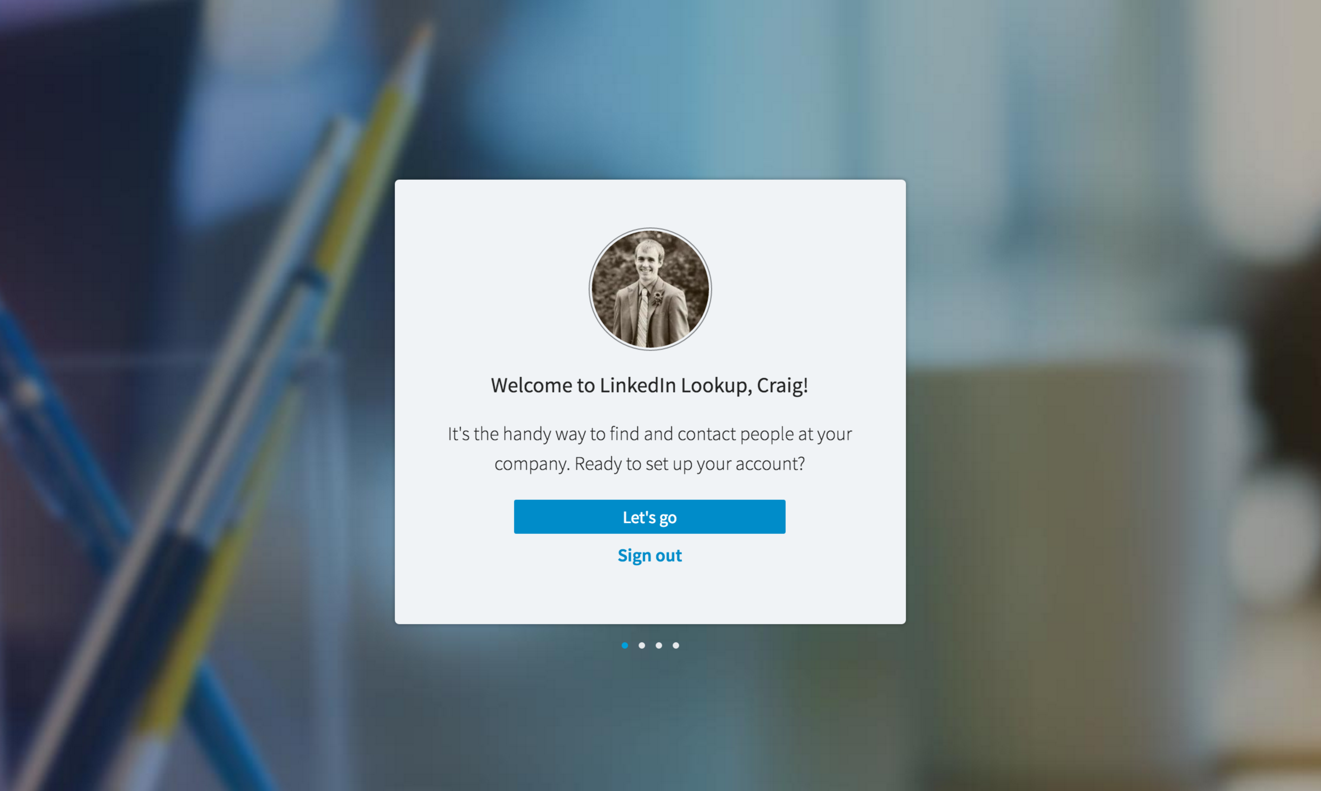

Notes:

* Didn’t I just do this? Yes I am ready, that’s why I clicked Get Started
* I thought the last page said coworkers, contacts, etc. Now this one just says in my company. Craig = Confused.

Get Started Walk-Through – Modal 2

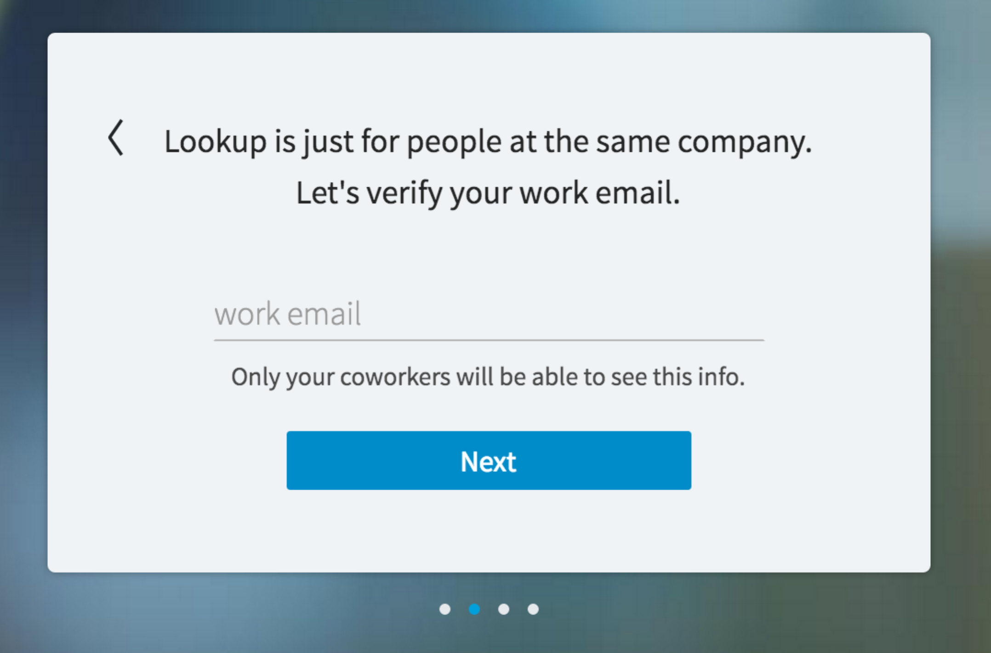

Notes:

* Alright now I know it is just the same company, I am less interested now, but I’ll bite.
* Why do you need my work email? Don’t you already know where I work?
* Why is this a verification step – I’ve never given you my work email.

Get Started Walk-Through – Modal 3

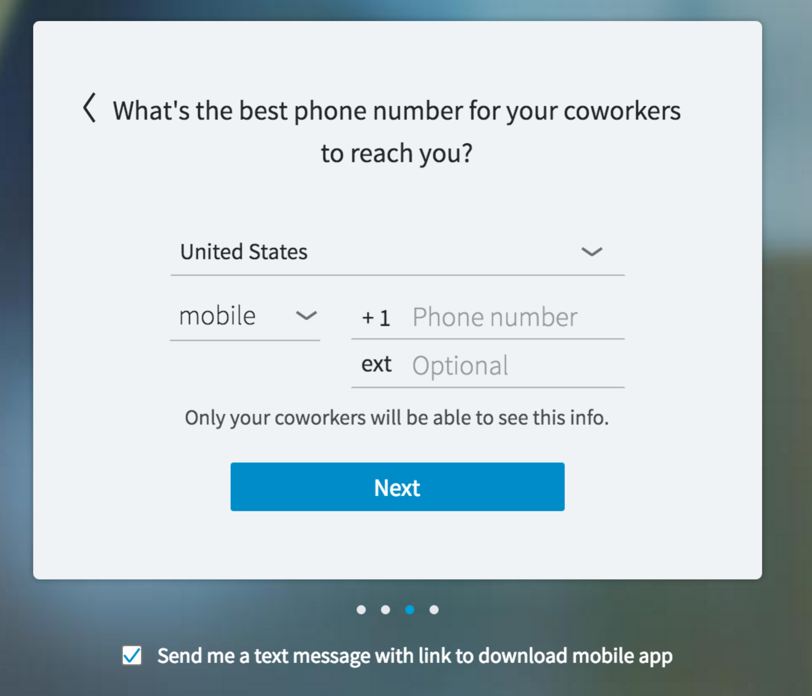

Notes:

* At this point I would bail. This is way too much commitment for something which has already failed to meet my expectations.
* I don’t want your app, I don’t even know what it does yet….
* Why do you need this? Is this Required?

Get Started Walk-Through – Modal 4

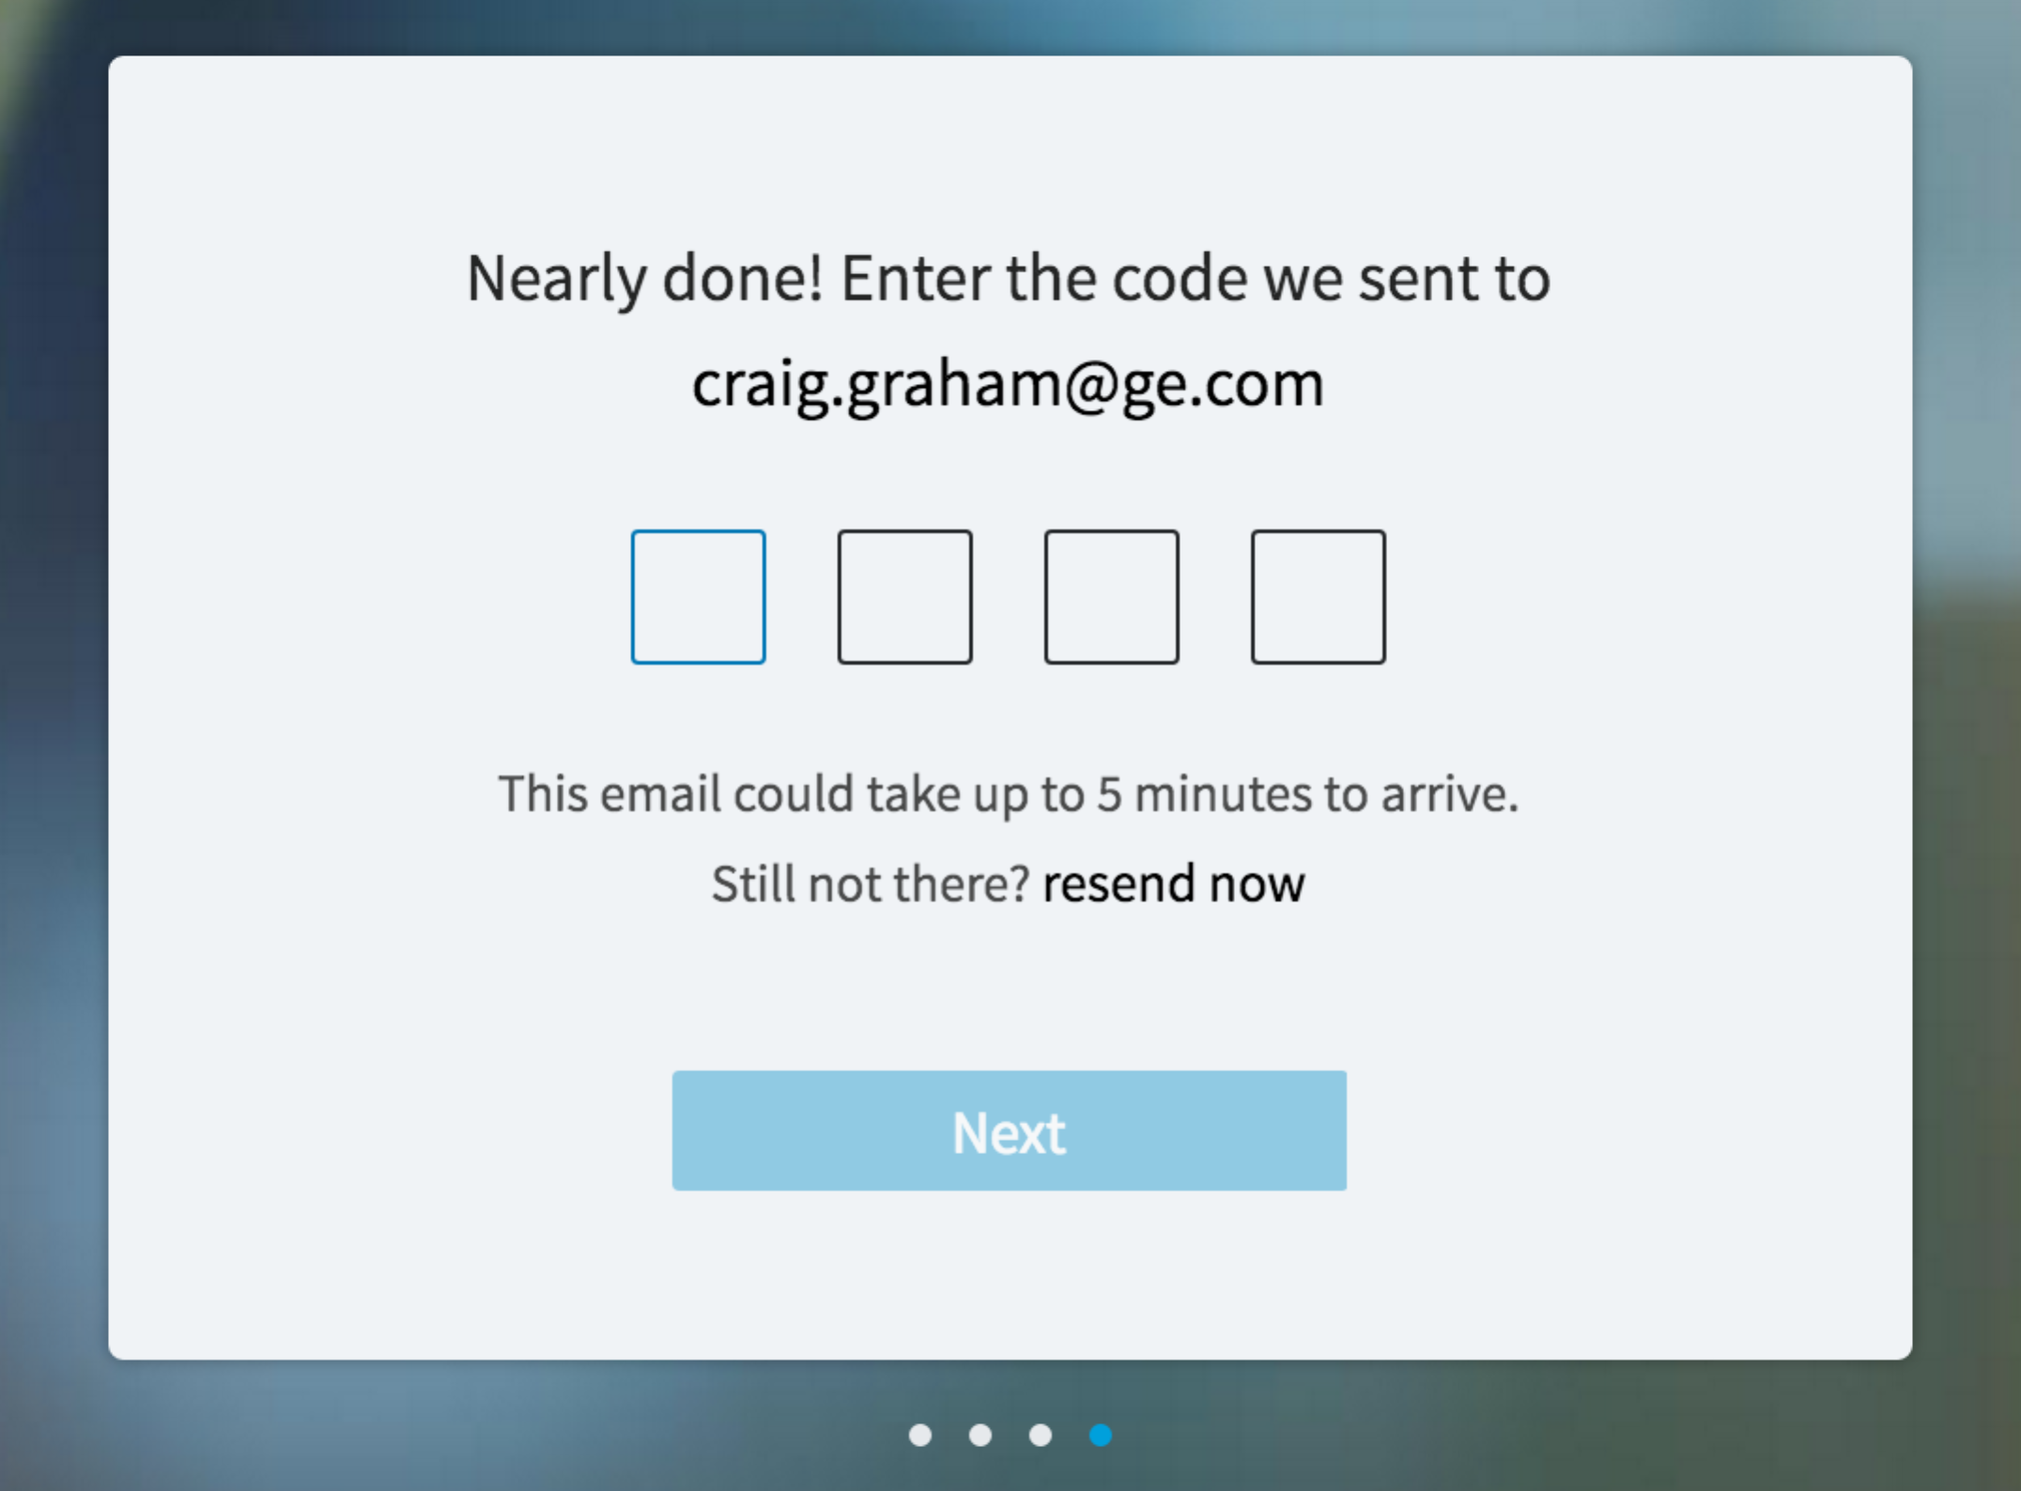

Notes:

* Regretting this…
* I don’t think this is technology required in order to accomplish what they are doing. This has the feel of “oh crap we need to get this out now – quick how can we ____”

Get Started Walk-Through Confirmation Screen

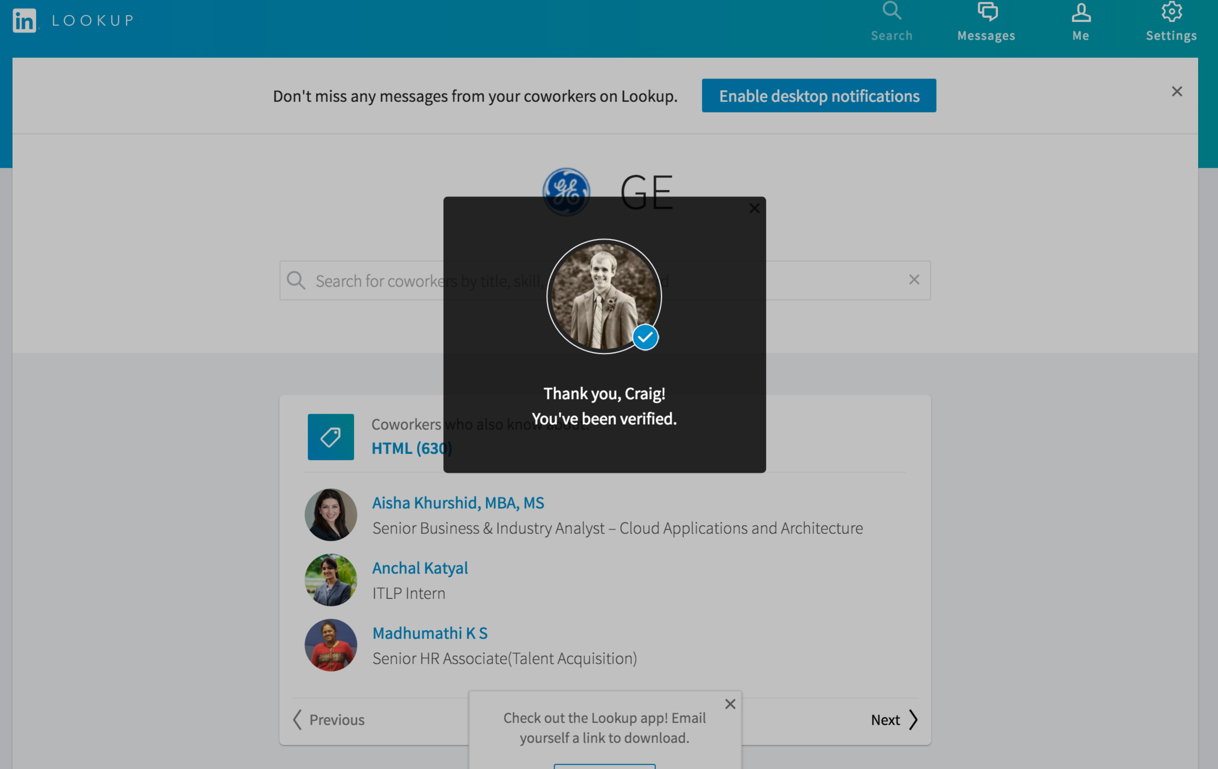

Notes:

* O Thank Goodness, I was worried there I wouldn’t be verifiable….
* How do I dismiss this thing? From what I can see behind the modal I just earned myself access to….something?
* Also…still don’t want your app.

Lookup Homepage

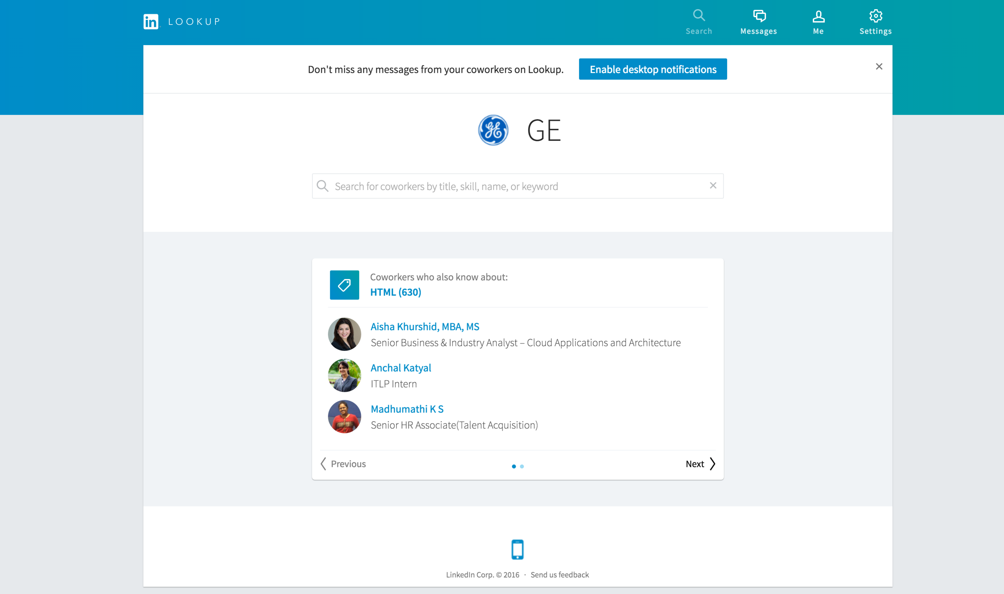

Notes:

* The others who know about HTML is an interesting idea, but it is so general it has no value to me. If it said, others who know about creating application for huge intranets and a population used to Web 1.0 apps, I might be more interested
* I don’t want your app, I don’t want your desktop notifications.
* Still not sure what this site will do for me, but the helper text on the search bar has peaked my interest.

Clicked on the Next Arrow on the CoWorkers who share something in common with me box

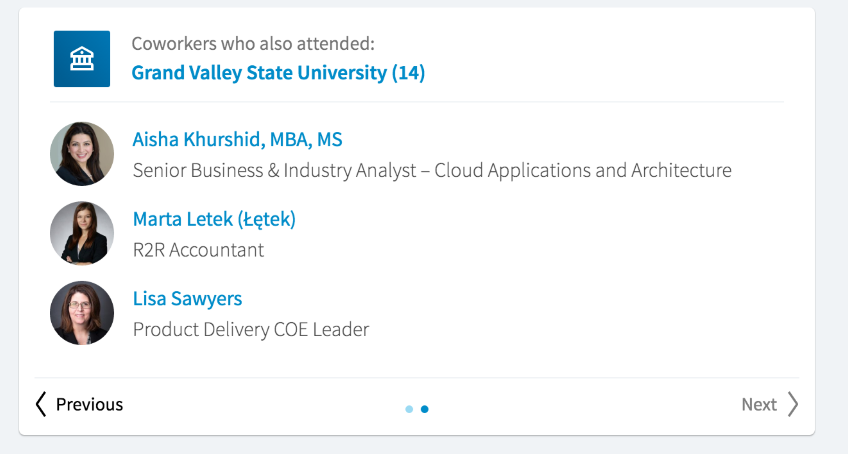

Notes:

* I expected this to show me the next page of people at GE who also know HTML, instead it showed me who else went to GVSU.
* This is slightly more interesting to me, but my mental model of how to interact with this box is completely broken. Now I have no idea to find the other 11 people who work at GE and went to GVSU.
* Clicking on the 14 does show me the rest of the folks who when to GVSU (including fearless leader)

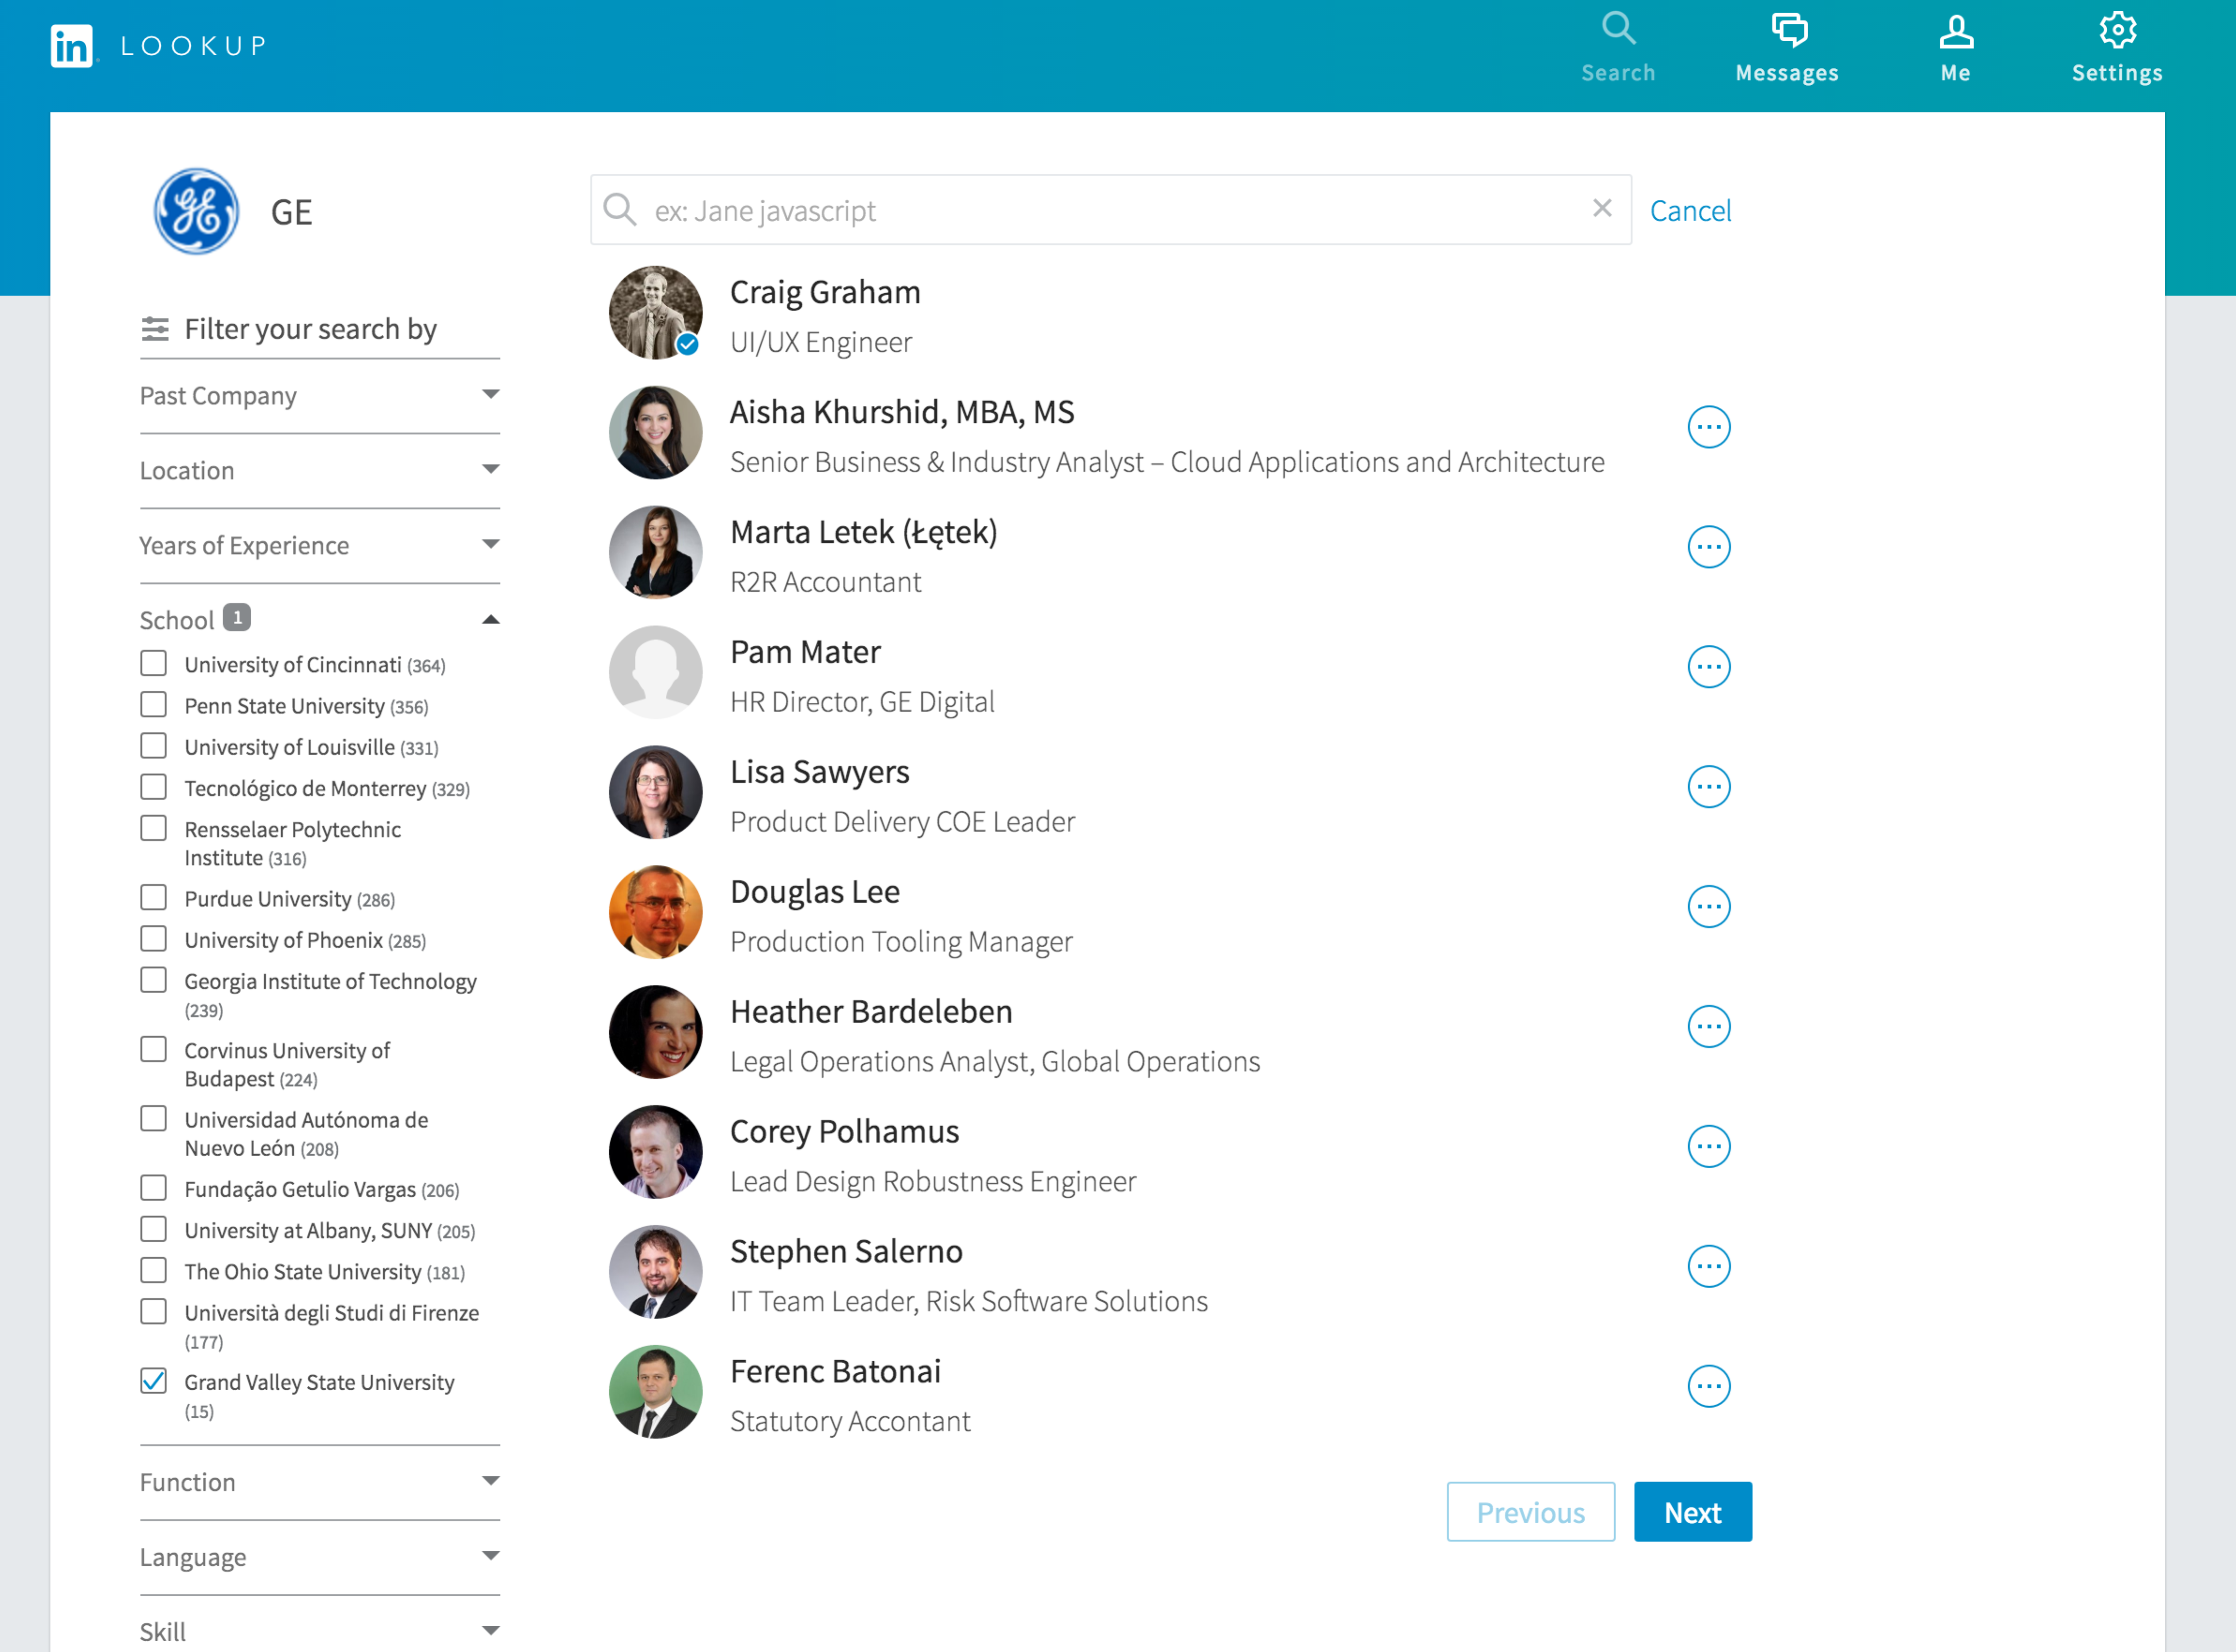

* Now that I am here there is actually no way to return to the homepage. Clicking the logo in the upper right or the back button does not succeed in getting me there, which is frustrating. In order to do a new search I have to unselected the GVSU school filter and then type my query.

First Search: “Angular 2.0”

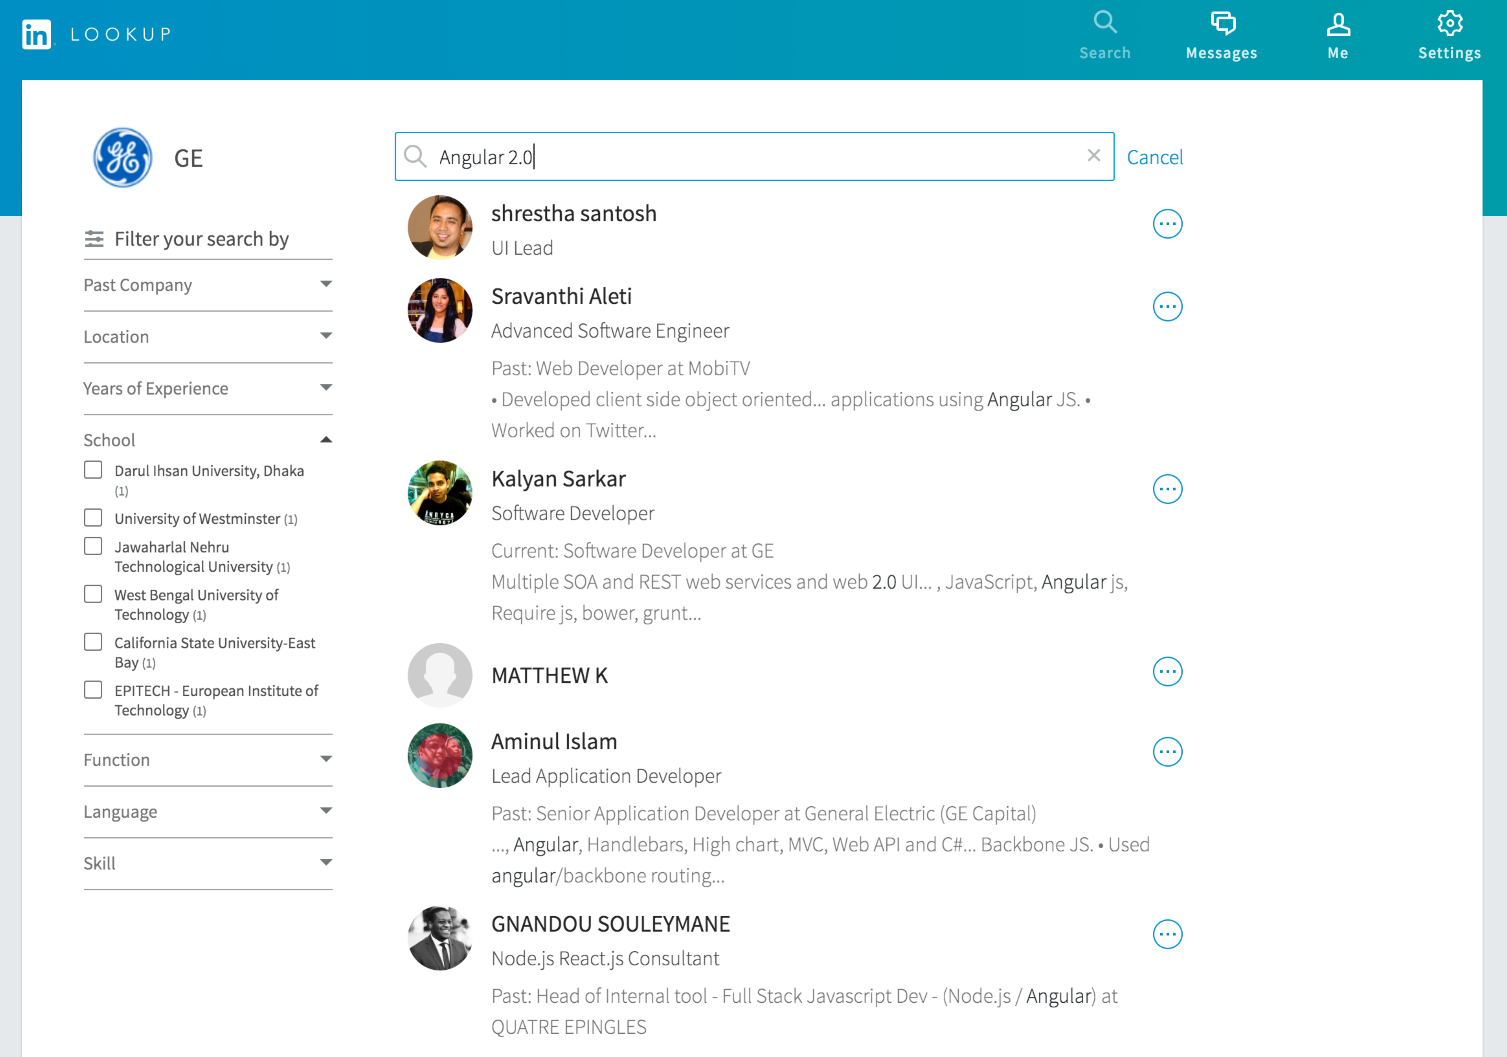

Notes:

* I am surprised that this came back with results.
* Based on the information presented here I can kind of pick the person who might best be able to help me with Angular 2.0. The highlighted portions of their profile helps
* I am not sure if any of these individuals are creditable or willing to field by questions so I am hesitant to contact them.
* UI speaking – this is strange. Why hide a menu with one option?

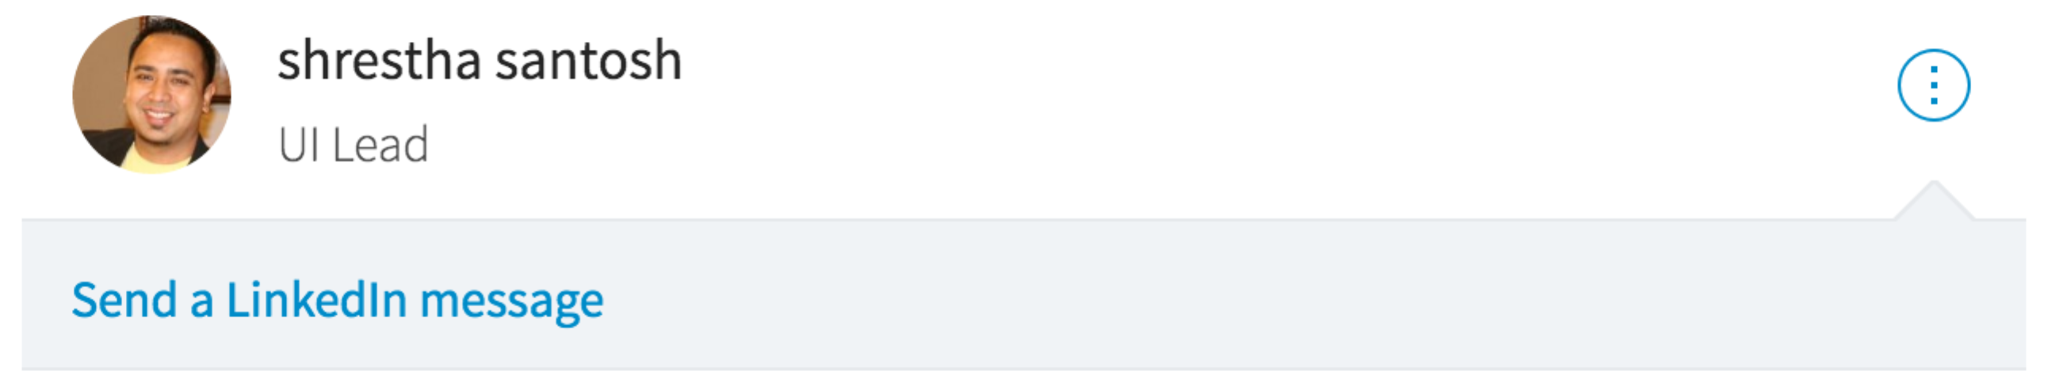

* Adding some filters (Skill: AngularJS & Years of Experience: 6-10) helps me get to a point where I am confident to click on Kalyan Sarkar

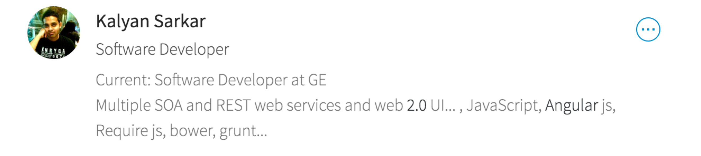

Kalyan Sarkar’s Lookup Profile

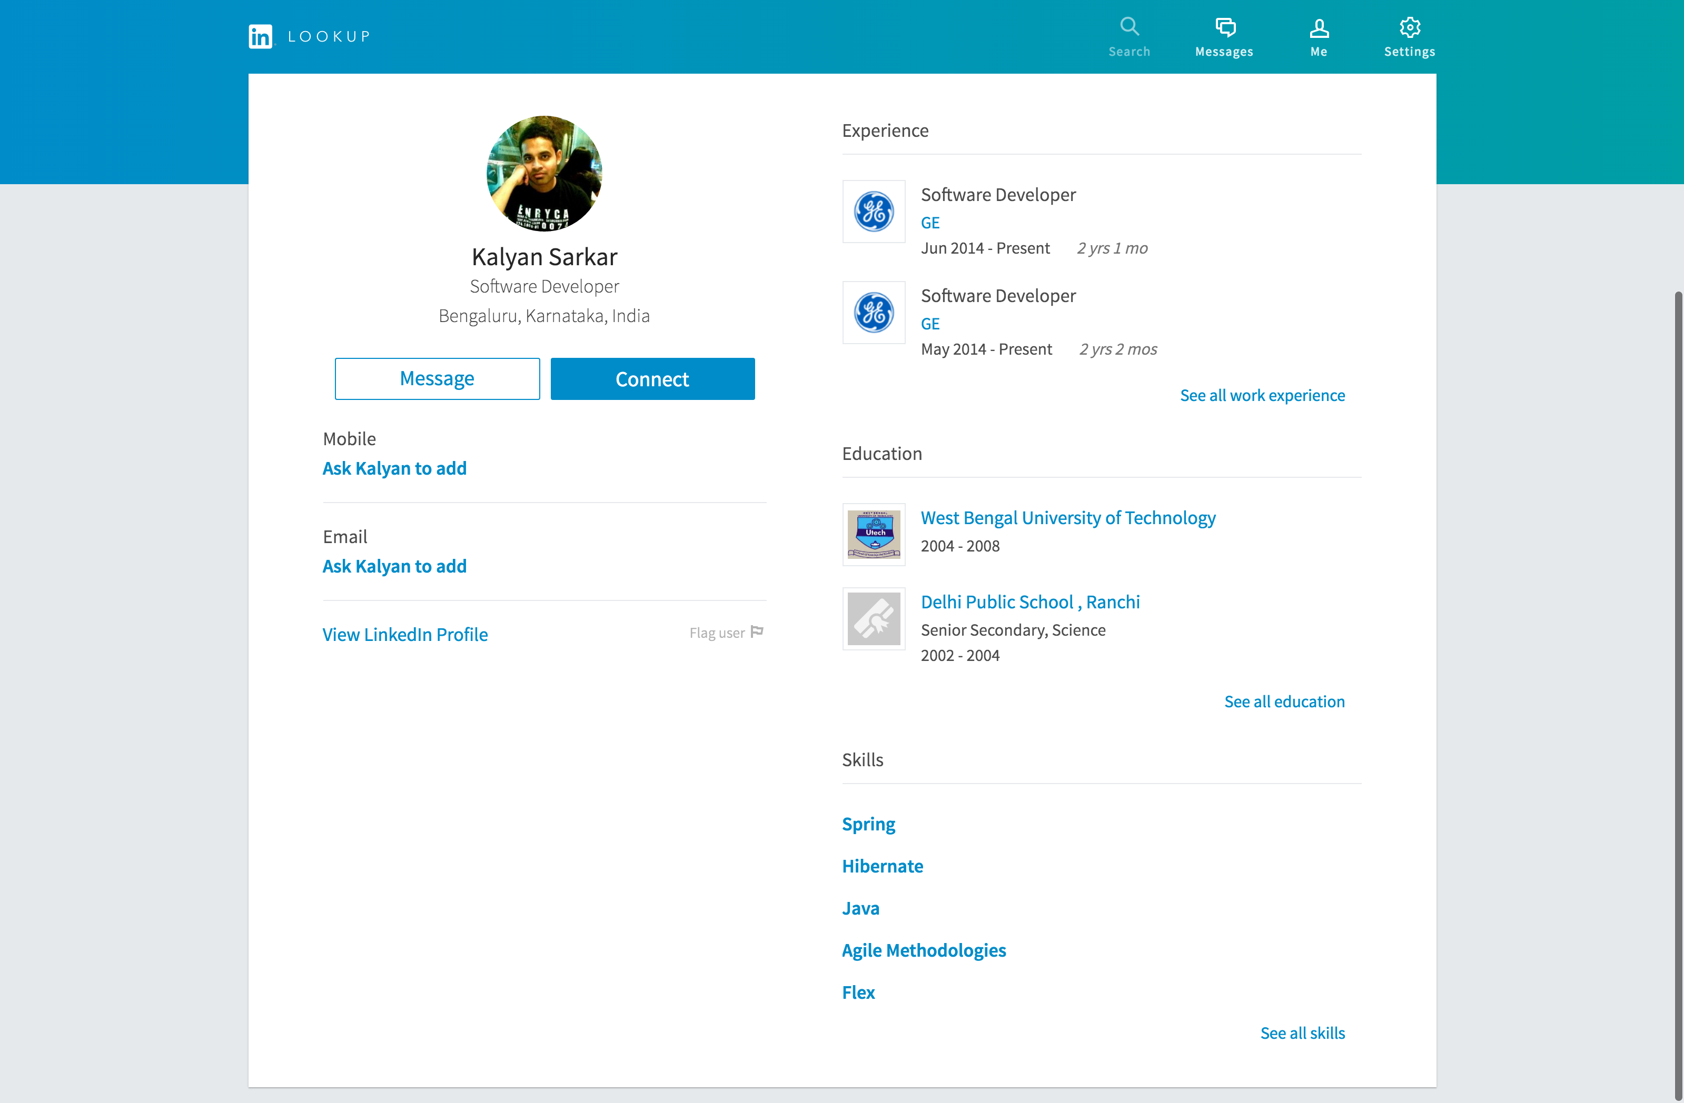

Notes:

* Not a whole lot of information here. As a matter of fact there seems to be less here than what I saw in the search results view
* To find out more about Kalyan I feel I need to view his Linkedin Profile, which is the small text – not bolded link on the bottom left.
* Clicking on that opens his profile (which is packed full of information) in a new tab (which is nice).
* During a quick scan of his profile I am able to find where the information in his search result list item was pulled from. This is the information I wanted. Now I am finally able to decide if I want to risk contacting Kalyan or not.

Interaction Cost – First Search

1. Decide what to search on
2. Look at search results
3. Read through experts of LinkedIn profiles in results list
4. Filter to find someone worth talking to
5. Re-Read Search Results
6. Click on user profile
7. Read User Profile to determine that there is not enough information here to decide if coworker is an expert in the skill I want to talk to them about
8. Locate how to find more about the coworker
9. Click to open full LinkedIn profile
10. Scan LinkedIn profile
11. Determine if the coworker is an expect
12. Close the full LinkedIn Tab
13. Find out how to contact Kalyan
14. Don’t want to connect – just want to message him.
15. No visible way to message Kalyan so I abandon the process.

Second Search – “GhostRed”

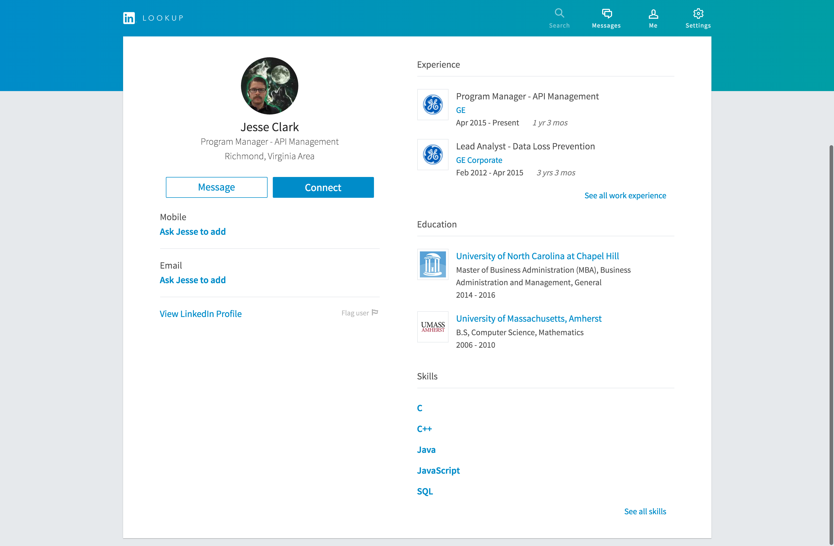

Notes:

* This search only came back with one result. I know this only because the search result page flashed with the single result list for a mere second before automatically directing me to Jesse’s Profile
* This is confusing, because it didn’t give me a profile for a search before.
  + Mental Model is confused again
* This page says nothing about GhostRed. I am unable to see why Jesse was returned, which is the most important connection I need to make.
* At this point I feel this tool is not as useful as actually just searching on LinkedIn.

Some Takeways

* **Starting Modals.** I actually didn’t mind going through this process if I would have learned something about what the product was going to do and if it didn’t ask so much of me (information I assume it knows or doesn’t need to know and lots of requests to download it’s app)
* **Homepage.** This page made the offerings purpose more clear and showed off the products ability to relate me to other people at GE, which did help build my confidence in the offering. The bummer was that they was no way to get back to this page.
* **Search Results**. Generally this page didn’t help me to determine if the person I was looking for was indeed one of the coworkers listed. The information I could filter could help me do some analysis to determine if the coworker is an expert in the thing I was looking for, but most likely it is just a word that appears somewhere in their profile – not helpful
* **Profile Page**. Not helpful at all! No information here – less than the search results page actually (which pulls information in from LinkedIn).

Conclusion:

I will save time if I just search on LinkedIn.